**TOUR CAO BANG- BAN GIOC**

*Attention:*

*-Departure point: Hanoi.*

*-Time: 3 days 2 nights.*

*-Media: car.*

*-Price: 2420000đ.*

*-Image:*

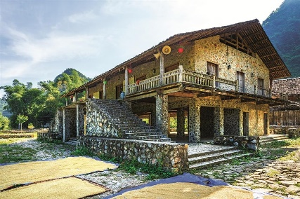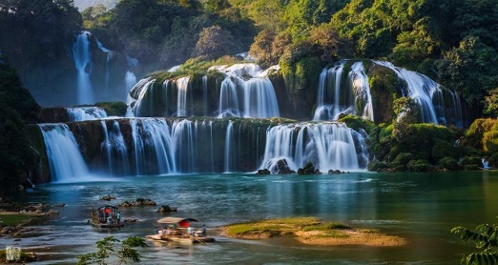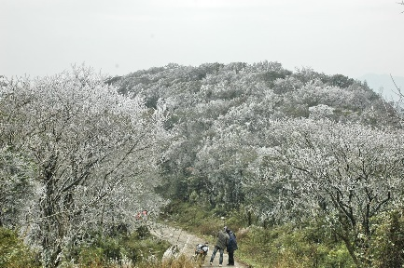

**I.** **Introduce:**

**TOUR CAO BANG- BAN GIOC**

The demand for traveling in the North is an inevitable trend, but the tourist areas and destinations are not many, so this year, mainly tourists come to the Northeastern mountainous region to visit historical sites. ... Among these are the itineraries Hanoi - Cao Bang - Hanoi. This is the travel route that many tourists this year choose for their journeys ...

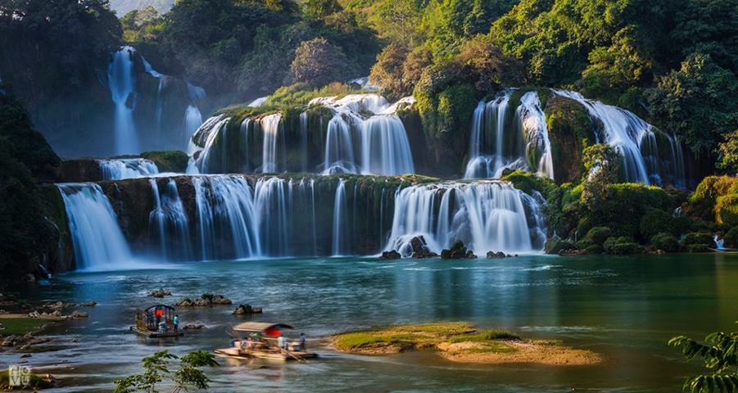

Ban Gioc is the most majestic and beautiful waterfall of Vietnam, located in Dam Thuy commune, Trung Khanh district, Cao Bang. Right from afar, tourists can hear the rushing waterfall. From a height of over 30 m, large bodies of water flow through many limestone steps. In the middle of the waterfall, there was a large rock tissue covered with trees, which saw the water split into 3 streams like three white silk bands.

Day and night, the waterfall rolls down on flat rocks, sending out countless white dust particles that cover a large area. On sunny days, the steam also creates a shimmering rainbow. At the foot of Ban Gioc waterfall is a wide, mirror-like surface of the river. The two banks are grass, green forest flap.

**II.** **Tour schedule:**

**1.Day 1:**

**HA NOI - CAO BANG**

_____________________________________________________________________

05h00: Car and guide of Viet Center welcome guests at the meeting point of departure to Cao Bang, you stop for lunch in Bac Kan, afternoon delegation to Cao Bang, visit Uncle Po Cave ...

You check in for dinner, free at night to roam to visit Cao Bang City at night. Overnight at hotel.

_____________________________________________________________________

**2.Day 2:**

**DISCOVER BAN GIOC**

_____________________________________________________________________

After breakfast, take the car to visit Ban Gioc Waterfall, a large and beautiful waterfall adjacent to the name of Vietnam and China. Lunch at the restaurant. Afternoon: Visit Ngom Ngao Cave. Car to take you to the hotel for dinner, overnight at the hotel.

_____________________________________________________________________

**3.Day 3:**

**CAO BANG - HA NOI**

_____________________________________________________________________

06h00: Have breakfast at the hotel, free shopping ... Get on the bus to depart for Hanoi. You stop for lunch in Bac Kan. Evening return to Hanoi, end the trip, goodbye and see you again!

_____________________________________________________________________

**III.** **INCLUDED AND TERMS:**

**Service includes:**

• Newer tourist cars, air-conditioned, shuttle to visit the program. • 3-star hotel: Viet Hung / Bien Me, etc. or equivalent (standard of 02 people / room, if male or female is combined with 3 guests). • Eating meals program. • 01 breakfast at the hotel • 03 main meals, standard 150,000 VND / meal / meal. • Professional tour guide, enthusiastic, thoughtful service throughout the trip. • Travel insurance by day tour, the maximum compensation of 10,000,000 VND / case. • Tourist hat, cold towels, drinks served on the tour. The service does not include: • Beverages: alcohol, beer, soft drinks and personal drinks not mentioned. • Personal expenses: minibar, laundry, shopping, telephone, sightseeing, extra-program transportation and VAT.